Recommended Pilot Supplies & Equipment
As a pilot you will acquire many types of equipment, supplies, books, and aids. Below is a list of items to consider. Items considered essential are marked with an asterisk **
Flight Training:
- Headset**
  - This is essential for training & learning as it is safer & less stressful to the pilot. Headsets come in all price ranges. ($100 to $1200).
  - I would recommend you buy a basic headset without Active Noise Reduction(ANR). There are many fine vendors (David Clark, FlightCom, SoftCom, Lightspeed, …etc) and you can find them at pilot shops listed below or even on Amazon or Ebay.
- Maps, Charts, & Flight Publications**
  - You must have current maps appropriate to the flight being conducted on board during any flight.
    - These can be paper (or electronic). As a student you will need some paper maps for flight planning and as a learning reference.
    - Typically, for training you’ll need the current STL Terminal Chart*, St. Louis Sectional, and Kansas City Sectional. Ask your instructor where you’ll be flying.
      - These can be bought at the Spirit Pilot Shop, Creve Coeur Airport Office, or online at mypilotstore.com (can also purchase a by-mail subscription here to ensure you always have current charts).
    - Even if you have an electronic map (and tablet app to display then), we all carry some paper map(s) as a backup.
    - All maps do have expiration dates so this is a recurring purchase throughout your aviation career.
    - 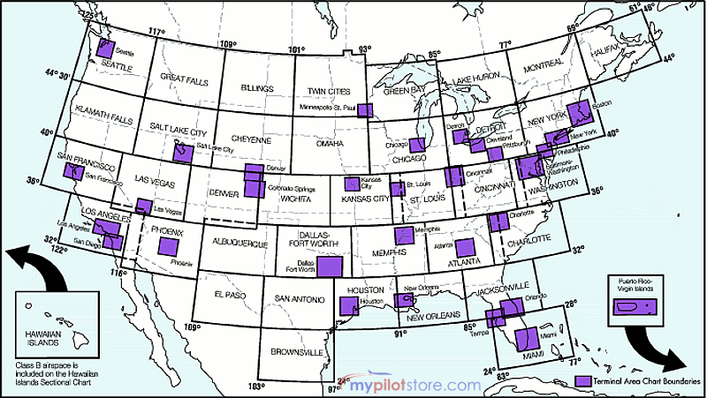
  - FAA Chart Supplements** (formerly Airport Facilities Directory, AFD)
    - These can be bought at the Spirit Pilot Shop, Creve Coeur Airport Office, or online at mypilotstore.com. NORTH CENTRAL
    - 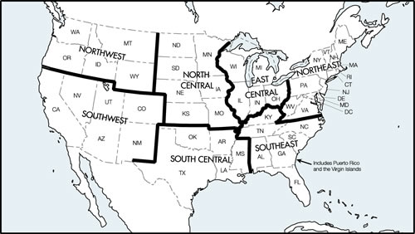
- Logbook**
  - We recommend this one, or a similar one during training.
  - There are small starter log books that you can get for free by completing an EAA Eagle Flight but you will eventually still transition to one like listed above.

- Fuel Sampler/Tester**
- Tire pressure gauge**
- Kneeboard
- Flashlight
  - You probably want one that can display both white and red. (red in the air, white on the ground). Headlamps are nice options here.

Ground School and Flight Planning:
- Ground School Class/ Exam Prep Books / Study Guide Software
  - There are many books by companies such as ASA, Gleim, Jeppesen, Sporty’s… etc
  - There are Videos sets and classes by these companies and King Aviation
  - There are many excellent Internet videos, many produced by schools such as N. Dakota
  - Finally, companies also have software for exam preparation for PC, Mac, Android, and iOS
  - Boeing has some help for ground school in the LTP program. See your benefits handbook.
- Aviation Books
  - Many excellent authors (Machado, King, Collins, Schiff, …)
- FAA Books/Pubs https://www.faa.gov/regulations_policies/handbooks_manuals/aviation/
(at some point you will have and read all of these):
  - FAR/AIM – Federal Aviation Regulations / Airman’s Information Manual
  - Pilots Handbook of Aeronautical Knowledge
  - Airplane Flying Handbook
  - Student Pilot Guide
  - Weight & Balance Handbook
  - Aviation Weather
- FAA Charts / Products
  - https://www.faa.gov/air_traffic/flight_info/aeronav/digital_products/vfr/
  - http://www.faa.gov/air_traffic/flight_info/aeronav/digital_products/aero_guide/
  - http://www.faa.gov/air_traffic/flight_info/aeronav/digital_products/dafd/search/

- POH – Pilot’s Operating Handbook** for your aircraft
- Flight Computer** / Calculator
- Plotter**
- WEATHER
  - NOAA Graphical Forecast for Central Mississippi Valley
  - Aviation Weather Center AWC - ADDS Wind Temp Data AWC STL Airports
  - Sunset sunset

- Flight planning / airports
  - AOPA Airport Dir https://www.aopa.org/airports/
  - FltPln.com http://fltplan.com/
  - AOPA weather https://www.aopa.org/wx/#chart=ussurf
  - SkyVector https://skyvector.com/
  - NavFinder http://airportnavfinder.com/airport/KSTL/
  - http://www.airnav.com/
  - https://www.globalair.com/airport/
  - http://www.dauntless-soft.com/products/Freebies/VFRFlightPlanner/

Miscellaneous Extras/Nice to haves for someday. Initially they won’t really help you
- Passenger Headset(s)
- Handheld Radio
- Tablet computer
- EFB (electronic flight bag) Software
  - This can run on tablet or phone
- Advisory Circulars / AC Subscriptions thru the FAA
Vendors:
www.mypilotstore.com
www.sportys.com
www.amazon.com
http://www.asa2fly.com/Default.aspx
Organizations:
www.AOPA.org www.EAA.org

